Wireshark Packet Analysis Report

1. Objective
The objective of this task is to capture and analyze network packets using Wireshark. The analysis focuses on identifying network protocols, understanding packet structures, analyzing TCP flags, and detecting unusual or suspicious network traffic.

2. Tool Used
Parameter | Specification
Tool | Wireshark
Operating System | Windows
Network Interface | Wi-Fi / Ethernet

3. Packet Capture and Protocol Analysis

A) HTTP Traffic Analysis
Wireshark Filter Used:
http
Observation:
- HTTP packets were captured successfully using Wireshark.
- HTTP requests and responses between the client and server were analyzed.
- HTTP communication was observed over TCP protocol.
- Common HTTP methods such as GET and response packets were identified.
- HTTP generally operates on TCP port 80.
Screenshot: 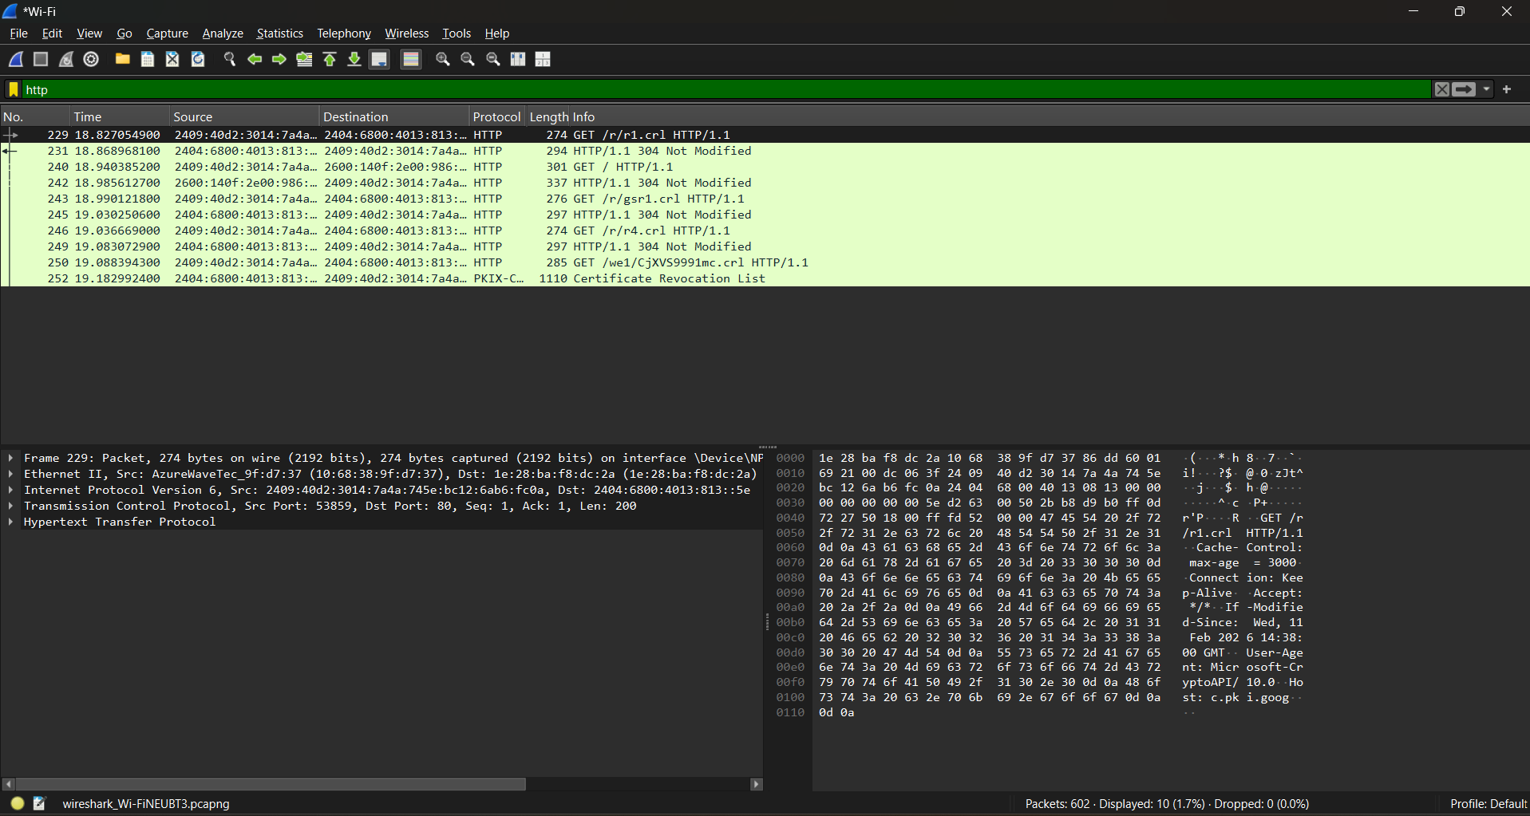

B) DNS Traffic Analysis
Wireshark Filter Used:
dns
Observation:
- DNS packets were captured and analyzed.
- DNS queries and responses were identified.
- DNS was used to resolve domain names into IP addresses.
- DNS communication was observed using UDP protocol on port 53.
Screenshot: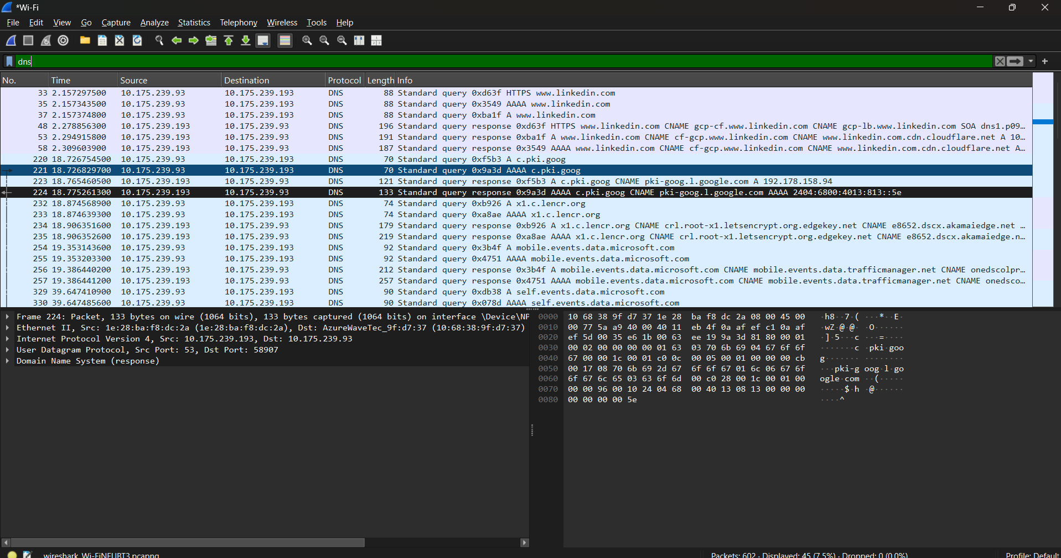

C) TCP Handshake Analysis
Wireshark Filter Used:
tcp
Observation:
The TCP three-way handshake was analyzed:
- SYN: Client sends a request to establish a connection.
- SYN-ACK: Server acknowledges the request and responds.
- ACK: Client confirms the connection establishment.
TCP Flags Observed:
- SYN (Synchronize)
- ACK (Acknowledgement)
- FIN (Finish)
- RST (Reset)
Screenshot: 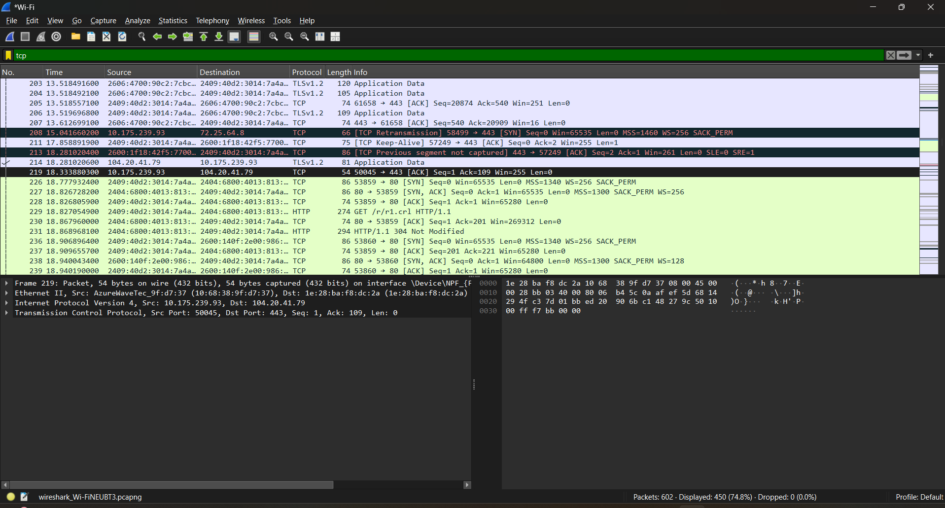

4. Packet Structure Analysis
Each captured packet was analyzed based on different protocol layers.
Protocol Layer | Information Observed
Frame Layer | Packet number, Packet size, Capture time
Ethernet Layer | Source MAC address, Destination MAC address, Ethernet protocol information
Internet Protocol (IP) Layer | Source IP address, Destination IP address, IP protocol details
Transport Layer | TCP/UDP ports, TCP flags, Sequence numbers, Acknowledgement numbers

5. Suspicious Traffic Analysis
The captured traffic was analyzed for possible security issues. The following checks were performed:
- Detection of unusual IP addresses
- Identification of malformed packets
- Checking TCP retransmissions
- Checking TCP reset packets
- Identification of unexpected protocols
Analysis Result:
No major suspicious or malicious traffic was detected during the packet capture. The observed packets appeared to be normal network communication.

6. Conclusion
Wireshark was successfully used to capture and analyze network traffic. HTTP, DNS, and TCP protocols were identified and studied. TCP handshake packets and network packet structures were analyzed to understand how communication takes place between devices.
This activity helped in understanding network monitoring, protocol analysis, and basic detection of abnormal network behavior.

7. Screenshots Attached
- HTTP Traffic Capture
- DNS Traffic Capture
- TCP Handshake Capture
- Packet Details Analysis
- Additional Wireshark Filters

